Lab-03 (tasks in the lab)

Task 01
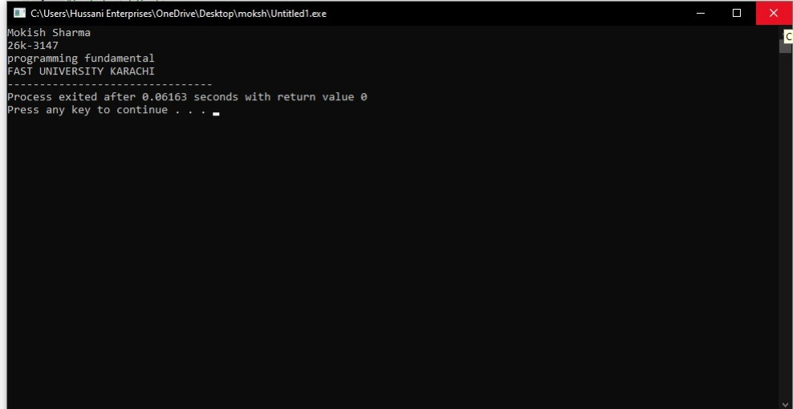
#include <stdio.h>
int main()
{
printf("Mokish Sharma\n"),
printf("26k-3147\n");
printf("programming fundamental\n");
printf("FAST UNIVERSITY KARACHI");
}

Task 02
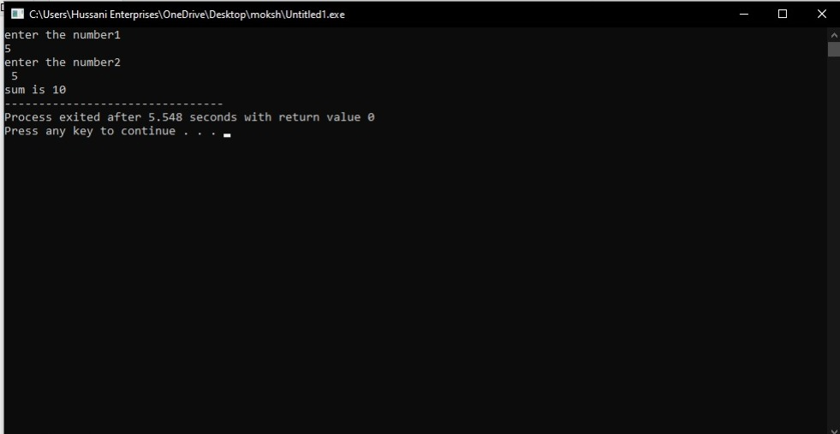
#include <stdio.h>
int main()
{
int number1;
int number2;
int sum=0;
printf("enter the number1\n");
scanf("%d", &number1);
printf("enter the number2\n ");
scanf("%d", &number2);

sum= number1+number2;
printf("sum is %d", sum);
return 0;
}

